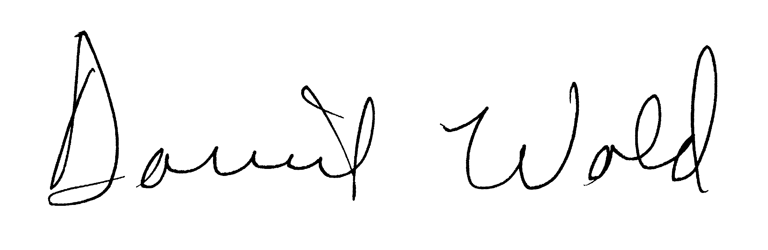
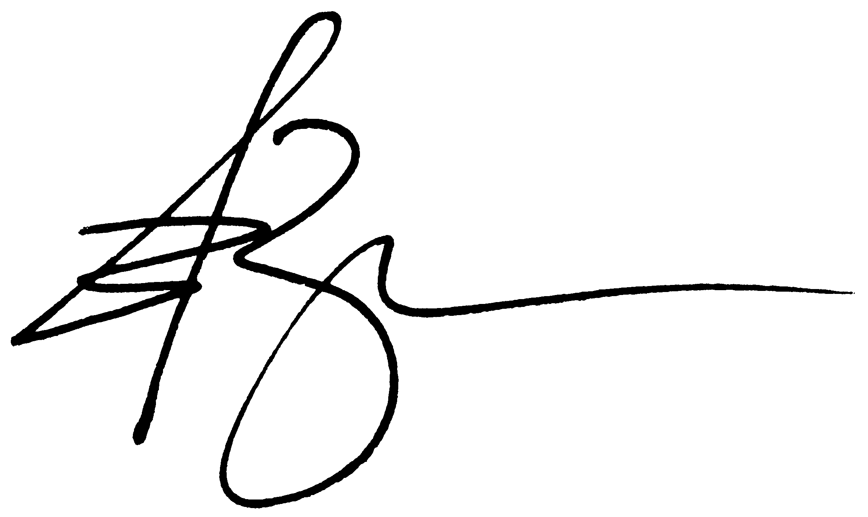
Preliminary Judicial Report

Issued By OLD REPUBLIC NATIONAL TITLE INSURANCE COMPANY
Guaranteed Party Name ORDER NO. 5501.0065

SCHEDULE A

See attached Exhibit “A”

SCHEDULE B
The matters shown below are exceptions to this Preliminary Judicial Report and the Company assumes no liability arising therefrom.

- Agreement for restrictions by and between Clifford Poppe and Alberta W. Poppe and Grace Faber Gelay recorded on January 23, 1941 as Volume 1892 Page 407 of Hamilton County, Ohio Records.

- Terms, conditions, and/or limitations of reservation of easement for joint driveway contained in the deed recorded on March 15, 1955, as Volume 2743 Page 19 of Hamilton County, Ohio Records.

- Easement for the purpose of utilities granted to The Cincinnati Gas & Electric Company from Roy A. Dryer, recorded on January 29, 1957 as Volume 2881 Page 375 of the Hamilton County, Ohio Records.

- Easement for the purpose of storm sewer granted to Clarence Gibs from Roy A. Dryer and Eleanor K. Dryer, recorded on March 4, 1957 as Volume 2887 Page 195 of the Hamilton County, Ohio Records.

- Terms, conditions, and/or limitations of recital of driveway easement contained in the deed recorded on March 27, 1998, as Volume 7609 Page 1287 of Hamilton County, Ohio Records.

- State Tax Lien filed against L S Hayes, (prior owner) 3229 Glengyle Ave., Cincinnati, OH 45208, in favor of State of Ohio Department of Taxation, in the amount of $267.43, recorded on April 25, 2000 as CJ00005587 in the Hamilton County, Ohio Records. NOTE: Unable to determine if our party.

- Hazardous Substances Certificate and Indemnity Agreement by and between Mesfun Elias and Advantage Bank recorded on February 12, 2007 as OR Volume 10471 Page 768 of Hamilton County, Ohio Records.

- Mortgage from Mesfun Elias, a single person, to Advantage Bank, 6360 Tylersville Rd., Mason, OH 45040, in the original amount of $70,000.00, dated June 17, 2008, recorded on June 30, 2008 as OR Volume 10888 Page 171 in the Hamilton County, Ohio Records. NOTE: The above being an Open End Mortgage. The legal descriptions set forth in the above mortgage and the current deed are not identical due to the legal on the mortgage includes a recital of the driveway easement.

- Foreclosure action pending in the Court of Common Pleas, Hamilton County, Ohio, Case No. A 1302947: Robert A. Goering, Treasurer Hamilton County, Ohio vs Mesfun Elias, et al, complaint filed April 18, 2013. NOTE: Docket does not reflect the filing of a military affidavit. No service found for Fifth Third Bank and State of Ohio Department of Taxation. NOTE: Case dismissed on May 14, 2013.

- Tax Parcel 128-1-161 has a land value of $21,430.00, a building value of $21,860.00 for a total value of $43,290.00. Taxes for the first half of 2012 are paid in the amount of $1,879.01. Taxes for the second half of 2012 are a lien, not yet due and payable. NOTE: $1,424.41 was paid for second half - balance due June 20, 2013 is $444.40. NOTE: Prior delinquent taxes paid in the amount of $4,340.56. Assessment for Urban forestry in the amount of $10.20.

OLD REPUBLIC NATIONAL TITLE INSURANCE COMPANY
A Stock Company
400 Second Avenue South, Minneapolis, Minnesota 55401
(612) 371-1111

ORT Form 4276 A & B
PJR 04/15/2010

By
Attest

President
Secretary

